**ADK (Python Programming) ROLL NO : 01**

**Aim**: Write the program for the following: (by using control statements and control structure)

**(F). Write a recursive function to print the factorial for a given number.**

**Theory: -**

**Practical Implementation:-**

**# python program to find the factorial of a number using recursion**

**def recur_factorial (n):**

**"""function to return the factorial of a number using recursion"""**

**if n == 1:**

**return n**

**else:**

**return n*recur_factorial(n-1)**

**# take input from the user**

**num = int(input("enter a number: "))**

**# check is the number is negative**

**if num < 0:**

**print("sorry,factorial does not exist for negative number")**

**elif num == 0:**

**print("the factorial of 0 is 1")**

**else:**

**print("the factorial of",num,"is",recur_factorial(num))**

**output:-**

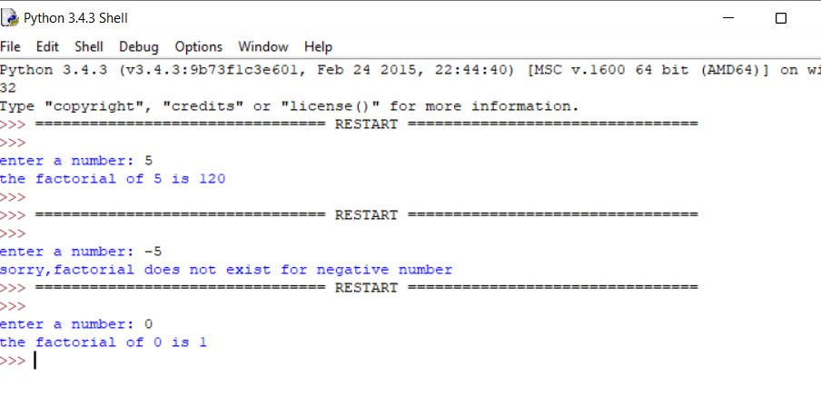

**Conclusion:**